2022 9th International Power Electronics Systems and Applications (PESA)

Title

Power electronics in modern power systems

Abstract

Power systems are in transition as a part of Green Transition. Traditonal fosil fuel based energy technology is being replaced by new and clean energy technologies. Many clean energy related technologies have been developed and utilized, e.g., wind and PV generators, green hydrogen electrolysis, heat pumps and various storages, etc. A new energy system is emerging with distinctive features, one of the features is that Power Electronics are gaining dominant role position in power grids, e.g., the interfaces of RE generators, energy storages and electrical vehicles, High Voltage Direct Current transmissions, Flexible Alternating Current Transmission Systems etc. The power systems are becomeing very different from the traditional fossil fuel-based technology based power system, which would significantly change the characteristics of power systems and present many challenges.

The speech will brief the development of power electronic technologies, in particularlly, the power electronic applications in power systems, such as power electronic interfaces for power generation, conversion and consummer utilisation technologies. It will discuss the new features and challenges, and the possible solutions. A short introduction about Aalborg University and some recent research work are also included.

Brief Bio
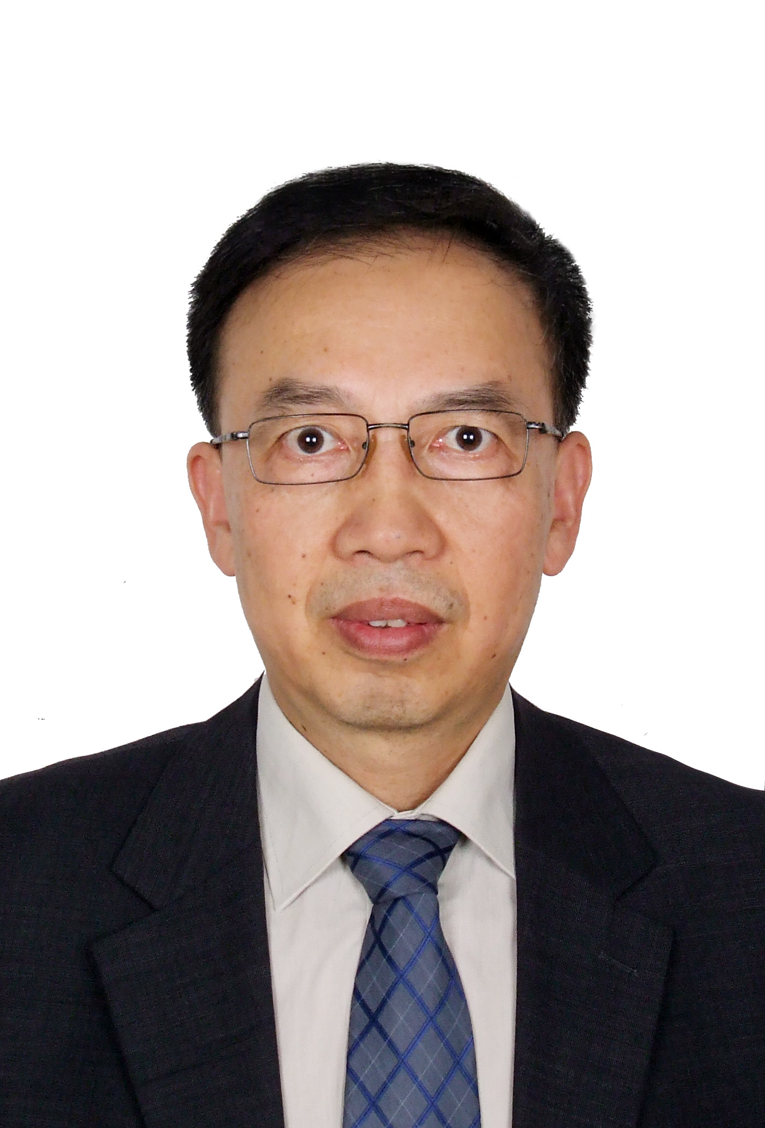

Zhe Chen
Dr Chen received his Ph.D. degree in Power and Control, from University of Durham, England, he has been a full Professor with the Department of Energy Technology, Aalborg University, Denmark since 2002.
Professor Chen is the leader of Wind Power System Research program at the Department of Energy Technology, Aalborg University. His main current research interests are wind energy, power electronics, power system and modern energy systems. In these areas, he has led many international and national research projects and has supervised many PhD, Postdoctoral researchers and more than 100 visiting scholars/visiting PhDs, has more than 800 technical publications. He is a panel member and a review expert for many international funding organizations.
Dr Chen is a member of editor boards of many international journals, including Associate Editor of the IEEE Transactions on Power Electronics, Subject Editor (wind turbine control) of IET Renewable Power Generation, etc. He is a Fellow of IET, a Chartered Engineer in the U.K., a Fellow of IEEE and a member of the Danish Academy of Technical Sciences.

